Free or Low-Cost Assistive Technology
This list of programs, software, websites, apps or browser add-ons focus on different forms of Assistive Technology Support.

Reading & Literacy Support

ABBYY TextGrabber
Features:
- Using the camera of your device, capture text and translate it using OCR
- Easily extract text from books, magazines, newspapers, ads, etc.
- Use VoiceOver (iPad only) to listen to your document in a text-to-speech format
- Captured text can be edited and/or copied to another source – 70 Languages!
- More Information: ABBYY TextGrabber Website
- Cost: Free with in-app purchases
- Compatibility: iOS; Android

Microsoft Immersive Reader
Features:
- Built-in text decoding solutions for students to assist with reading
- Enhanced dictation, focus mode, immersive reading, font spacing, short lines, parts of speech supports, syllabification, and comprehension mode
- More Information: Immersive Reader
- Cost: Free add-in through Office 365
- Compatibility: Mac OS, iOS, Windows OS

Speechify
Features:
- Have text read out to you in natural-sounding human voices using AI technologies.
- Upload documents into the application
- Have your text read in a variety of languages
- More Information: Speechify Website
- Cost: Free and in-app purchases
- Compatibility: iOS; Android; Online Resource

NaturalReader
Features:
- Text-to-Speech software which converts Microsoft Word, Webpages, PDFs, and Email into spoken text
- Customize reading voice and speed for your readings
- Floating toolbar to read text in other applications
- Online Text-to-Speech program with options to input text from various sources on your computer
- More Information: NaturalReader Website
- Cost: Free
- Compatibility: Windows; Mac OS; mobile App, Chrome Extension

Dolphin EasyReader
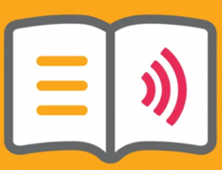
Features:
  - Reading app with customizable settings for the reader’s preferences
  - The app offers magnification, bookmarks, change in font size and color, and text audio
  - Works with a variety of file formats: HTML, Text files, DAISY files, Word documents, PDFs, and copied text
  - Syncs with Bookshare
  - More information: Dolphin EasyReader
- Cost: Free
- Compatibility: iOS; Android

Cometdocs PDF Converter
Features:
  - Create and convert PDF documents to Word, Excel, PowerPoint, Images, and other formats
  - Use within Google Drive with the converted documents waiting for you there
  - Use the web application, desktop app or app on your iOS device to convert documents too
  - More Information: Cometdocs Website
- Cost: Free
- Compatibility: Online Resource; iOS; Android

Rewordify
Features:
- Rewordify replaces higher-level vocabulary with words that are
easier to understand
- Help build understanding within readings and builds vocabulary
- Difficult words are replaced and highlighted
- Click on the words that were replaced to see the original word in
the text
- More Information: Rewordify Website
- Cost: Free
- Compatibility: Online Resource

Beeline Reader
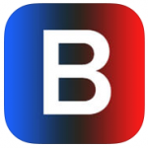
Features:
- Monochrome color text reader with Open Dyslexie Font
- Read PDF files, webpages and convert ebooks to PDF files to be read with this program
- Monochrome color text helps eyes to track lines of text for easier, faster reading by eliminating “line transition errors.”
- Various monochrome color schemes for personalized use
- More Information: Beeline Reader Website
- Cost: $4.99 – iOS app; browser extensions free
- Compatibility: Browser Extension: Chrome & Firefox; iOS

Books and Media for People with Print Disabilities

Open Library
- Features:
- A collection of ebooks
- Browse by subject, book title, or author
- Ability to create an account
- More Information: Open Library Website
- Cost: Free

Bookshare
Features:
- Largest online library of accessible reading materials for people with print disabilities
- Accessible books, textbooks, newspapers and magazine are available
- Individuals with Print Disabilities can sign up for a membership
- Books available for download can be read on DAISY players, with Screen Readers, Refreshable Braille Displays, and other Assistive Technology Programs
- More Information: Bookshare Website
- Cost: Free for qualified U.S. students and schools, and less than $1 per week for other members
- Compatibility: Online Resource

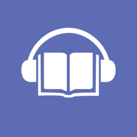

Internet Archive

Free books, journals, magazines as well as video, software and audio for the people with disabilities that impact reading. Over 65 million items.

More Information: Archive.org
- Cost: Free for qualified individuals.
- Compatibility: Online Resource

Writing Tools
The following Free or Low-Cost Assistive Technology programs, software, websites, and apps focus on different forms of writing support.

LanguageTool
Features:
- Free AI-based grammar and spell checking tool
- Available for more than 25 different languages
- The free version can check up to 10,000 characters
- Style suggestions are available in the premium version
- More Information: LanguageTool Website
- Cost: Free for basic and $4.99/month for premium version
- Compatibility: Online Resource and Chrome Extension

ProWritingAid Grammar Checker & Writing Coach
Features:
- Writing editor Chrome extension
- Works within websites, emails, Google Docs and other online sources
- With the free version, it scans the first 500 words for various categories in your writing, such as grammar, style, spell checking, word overuse, and more
- More Information: ProWritingAid Website
- Cost: Free for limited version or $20/month for premium version
- Compatibility: Free Chrome Extension and Online Editor

QuillBot
Features:
- AI paraphrasing, summarizing, and grammar checking writing tool
- Checks for grammar, provides synonyms and rephrases suggestions for up to 125 words at a time
- 1200 word limit for the summarizing feature and includes a free word counting tool as well
- More information: QuillBot Website
- Cost: Free and premium versions
- Compatibility: Online editor, Chrome Extension, Microsoft Word Extension

Vision
The following free focus on different forms of Vision Support.

NVDA Screen Reader
Features:
- NonVisual Desktop Access (NVDA) is a free, open-source screen reader built for Windows based operating system computers
- Download to your computer directly or to a USB drive and run on any computer without installation
- Works with many popular applications such as web browsers, email, and Microsoft Office programs
- Ability to convert text into a Braille using Refreshable Braille Display
- More Information: NVDA Website
- Cost: Free
- Compatibility: Windows

Be My Eyes
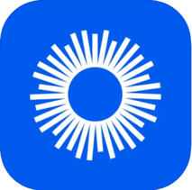
Features:
- Free mobile app for blind and low vision individuals for visual assistance
- Sets up a video call with the user and a sighted volunteer
- More Information: Be My Eyes Website
- Cost: Free
- Compatibility: iOS; Android

Fokus
Features:
- Highlight only the text you want to read while Fokus dims and darkens the rest of your Chrome or Firefox window with an overlay
- Highlights the paragraph you’re reading with the ability to change the opacity of the background overlay
- Easy to install extension with the ability to turn the feature on or off
- More Information: Fokus Chrome Extension
- Cost: Free
- Compatibility: Chrome Extension and Firefox Add-On

High Contrast
Features:
- Google accessibility extension for high contrast
- Contains various options for default color schemes for user’s preference
- Keyboard shortcut to enable or disable extension
- More Information: High Contrast Chrome Extension
- Cost: Free
- Compatibility: Chrome Extension

Hearing and Auditory
The following Free or Low Cost Assistive Technology programs, software, websites, and apps focus on different forms of Hearing and Auditory Support.

Ava
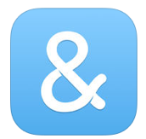
Features:
- Real-time closed captioning for what is being said around the user
- Use the app in meetings or conversations to see what people are saying
- Caption one-on-one conversations or group conversations
- Edit and Save transcript
- More Information: Ava Website
- Cost: Free or $9.95 per month for Premium
- Compatibility: Mac, Windows OS; iOS; Android

CaptionMate
Features:
- Real-time Captioning through AI technology for phone calls
- View conversations on phone, tablet, or computer
- Captions in 100 different languages
- Not intended for in-person events, but can be used for any event that you can dial into
- More Information: CaptionMate Website
- Cost: free
- Compatibility: iOS; Android

Live Transcribe & Sound Notifications
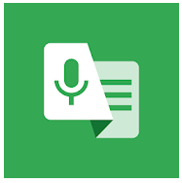
Features:
- Speech recognition software that generates real time transcriptions on Android devices
- Set custom notifications
- Save past transcriptions
- More Information: Live Transcribe & Sound Notifications Application
- Cost: Free
- Compatibility: Android

Otter.ai
Features:
- Has a live transcribe feature for audio that utilizes AI software
- The mobile and online platforms allow users to record, create notes from live transcripts, and share notes with others
- Works with Zoom
- More Information: Otter.ai Website
- Cost: free and $8.33 USD /month for Pro
- Compatibility: iOS; Android

Built-In Operating Systems Accessibility Tools
The following details Built-In Accessibility features on Windows, Apple, and Android.

Windows 10+ Microsoft 365 Products
Features:
- Personalize your Windows Computer with any of the built-in Accessibility Features to support ease with vision, hearing, mobility, and learning
- Features include Screen Reader/Text-to-Speech (Narrator), Magnification (Magnifier), Keys Commands (Mouse Keys), Speech-to-Text and Voice Control (Speech Recognition), Visual Notification to replace sounds, Keyboard on Screen, Toggle Keys, Adjustable Mouse Settings, High Contrast Schemes, Ability to Personalize the Appearance of the Computer including text, and more
- Tutorial videos and help guides are available
- More Information: Microsoft’s Accessibility Website
- Cost: Free
- Compatibility: Windows 10+

Apple Products
Features:
- Personalize your Mac Computer with any of the built-in Accessibility Features to support ease with vision, hearing, reading, mobility, and learning
- Features include Text-to-Speech, VoiceOver, Zoom, High Contrast, Sticky Keys, Speech-to-Text and Voice Control (Speech Recognition), Word Completion (Word Prediction), and more
- More Information: Apple’s Accessibility Website
- Cost: Free
- Compatibility: Mac, iPhone, iPad

Android OS
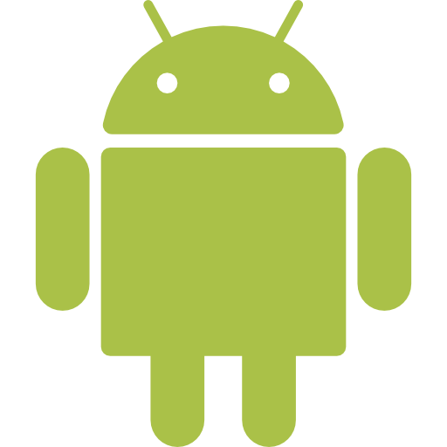
Features:
- Android devices have a series of apps and built-in accessibility tools. The Android Accessibility Suite is available to install on Google Play
- Features include Live transcribe, TalkBack, Live caption, Switch Access, Voice Access, and Sound Amplifier
- More Information: Android’s Accessibility Website and Android Accessibility Overview
- Cost: Free
- Compatibility: Devices Running Android OS.

Notetaking Support
The following Free or Low-Cost Assistive Technology programs, software, websites, and apps focus on different forms of Notetaking Support.

AudioNote 2
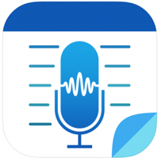
Features:
- Synchronize your notes with the audio recording of your lecture
- Take hand-written with Pen stylus or type notes
- Import lecture slides as the background to your notes
- More Information: AudioNote Website
- Cost: Free and in-app purchases
- Compatibility: Windows; Mac; iOS; Android

Microsoft OneNote
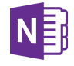
Features:
- Take all your notes in OneNote by typing, writing with a touchscreen, importing pictures, video, web links, and other resources
- Ability to record your lectures
- Pen stylus support
- Divide up classes and work by notebook, section, and pages
- Using OneDrive online, share your OneNote document for others to work on and interact
- Search your notes for the ability to easily find what you need
- More Information: OneNote Website
- Cost: Free with Office 365 account
- Compatibility: Windows; Mac; iOS; Android

Notability
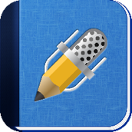
Features:
- Write, type, or annotate using highlighters your notes using the all in one notetaking app
- Ability to take pictures and audio record with the sound being linked to your notes
- Use Google Drive, Dropbox and Box to import, export and share documents such as PowerPoints and take notes directly on them
- Organize all your notes in one place
- More Information: Notability Website
- Cost: Free App With Annual Subscription Option of $11.99/year
- Compatibility: Mac; iOS

SoundNote
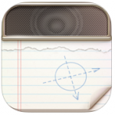
Features:
- Type or write out your notes while the audio recording is synced to each word or pen stroke
- Tap on the word and then the play button to playback what was being said at that moment in the audio recording
- Share your audio recording and notes via email, Dropbox, or transfer directly to your computer
- More Information: SoundNote Website
- Cost: $4.99
- Compatibility: iOS: iPad, Mac OS

YiNote by TurboNote
Features:
- Take notes while watching videos
- Generate a PDF of notes
- Includes timestamps of notes
- By clicking on the timestamps generated with the notes, this will take you to the exact place in the video the note was taken
- Ability to watch videos with multiple people at the same time with the same notes
- More information: YiNote Chrome Extension
- Cost: Free
- Compatibility: Chrome, Firefox, and Edge extension

Notebook – Notes, To-do, Journal
Features:
- Create personalized notebooks with customizable style settings
- Insert audio recordings up to 30 minutes and supplemental images within your notes
- Allows for drawing, tagging notebooks for easy navigation, adding to-do list items, and setting reminders
- More information: Notebook Website
- Cost: Free
- Compatibility: iOS; Android; Mac; Windows; Online Resource

TD Talk
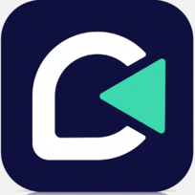
Features:
- Text-to-speech communication app
- Create phrases and select from various voice options
- Offers word prediction when typing
- Customizable keyboard settings
- More information: TD Talk Website
- Cost: Free
- Compatibility: iOS

Dictation/Speech-to-Text/Speech Recognition
The following Free or Low-Cost Assistive Technology programs, software, websites, and apps focus on different forms of Dictation/Speech-to-Text/Speech Recognition Support.

Dictation for Gmail
Features:
- Speech-to-text Chrome extension to assist with dictating emails
- Built into Gmail account
- Supports 60 languages
- More Information: Dictation for Gmail Chrome Extension
- Cost: Free
- Compatibility: Chrome extension

Speechnotes
Features:
- Speech to text tool only for dictation
- Offers a distraction-free environment
- Allows for the ability to create new sessions, save to Google Drive, email, save to computer, and print
- Zoom options available
- More Information: Speechnotes Website
- Cost: Free
- Compatibility: Online Resource; Chrome Extension; Android

Dictation.io
Features:
- Speech-to-text web application
- Allows for the ability to copy, save, publish, tweet, play, email, or print dictated text
- Supports 100 languages
- More Information: Dictation.io Website
- Cost: Free
- Compatibility: Online Web Application for Chrome Browser

Voice Control for Mac, iPad, iPhone
Features:
- Control a Mac, iPad, iPhone by voice
- Used with Siri speech-recognition engine
- Customizable vocabulary for commands
- More Information: Voice Control Apple Support Website
- Cost: Free
- Compatibility: Mac, iOS: iPad, iPhone

Voice Recognition in Windows 10
Features:
- Control a computer by voice
- Trains to the user’s voice
- Uses commands to navigate a computer
- More Information: Voice Recognition Support Website
- Cost: Free
- Compatibility: Built-In to Windows Operating System

Voice Typing in Google Docs
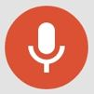
Features:
- Go into your Tools menu in Google Docs and select Voice Typing
- Click on the microphone that pops up and start talking
- Your text will be entered into the typing field
- Correct mistakes without moving your cursor
- No training needed
- More Information: Google Voice Typing Support Website
- Cost: Free
- Compatibility: Built-In Chrome Browser Option

