Crafton Hills College  Professional Development Minutes |  | Date: Nov 21, 2014  Time: 12:00 – 1:00 p.m.  Location: LRC-107
The Professional Development Committee seeks to involve the entire campus in learning activities characteristic of the very best teaching and learning organizations. The Committee places the highest value on activities that help people realize their individual and collective aspirations, raise the quality of their reflection and conversation, and hone their conceptualizations of the larger system in which their work is situated. In addition, the Committee actively seeks to help people to take advantage of learning opportunities with other institutions, organizations, and professional networks that fulfill our mission as a community college.

Educational Master Plan Strategic Directions
1. Student Access and Success  2. Inclusiveness  3. Best Practices for Teaching and Learning  4. Enrollment Management | 5. Community Value  6. Effective, Efficient and Transparent Processes  7. Organizational Development  8. Effective Resource Use and Development

Members: (bold = presence)  Breanna Andrews  Daniel Bahner  Ryan Bartlett  Robert Brown  Karen Childers  Robert Crise
  Kristin Garcia  Tina Gimple (co-chair)  Rick Hogrefe  Marina Kozanova  Lynn Lowe  Luis Mondragon | Daniel O’Hare  Dean Papas (co-chair)  Bryan Reece (co-chair)  Sam Truong  Jim Urbanovich (semester abroad)  Cindy Omana (student Services rep)

Guests: Rhiannon Lares, Shave Veloni, Trisha Menchaca, Wayne Bogh, Debbie Bogh
AGENDA ITEM | DISCUSSION |  | FURTHER ACTION
Call Meeting to Order | 12:00pm
Approval of Minutes | Approved (MCS)
New Business  - Funding Request | - Hannah Sandy: request of $500 (MCS) Approved. |  | Bob: Inform Hannah that her funding request was approved.
- Planning for Part-time Orientation, In-Service, and Flex Days | 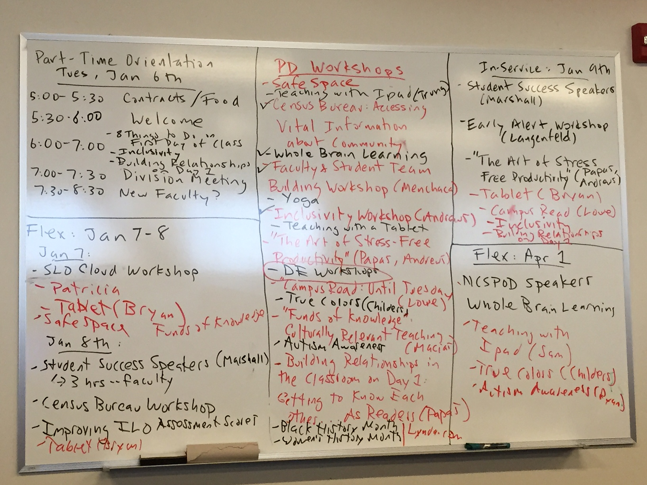  - Bryan: We need to develop a standing budget for presenters. For example: $250 for each new presentation development/presentation, and $100 for each repeat presentation given.  - Dean: We need to set up a workshop to help people walk through Lynda.com |  | Dean: Solidify dates, presenters, and rooms for flex days and send to Robert.  AND  Agendize “Work on PDC budget. All presenters should get paid for their presentations”  Robert: compile Flex day fliers and send out
Other Issues/ Announcements | Safe Space and Campus Diversity Posters were passed out to have people hang in their work spaces.
Future Agenda Items and Important Dates | - Classroom Inclusivity (LGBTQ) presentation (Breanna)  - Future Book Club idea: “Whole Brain Teaching” by Chris Biffle (Marina)  - List of common conferences throughout the year (Daniel)  - The deans discussed setting aside money for professional development conference attendance (Bryan)  - Part-Time Orientation: January 6, 2015  - In-Service Day: January 9, 2015  - Spring Flex Days: January 7-8 and April 1, 2015
Adjourn | 1:15pm |  | Next Meeting:  January 16, 2015
Mission Statement  To advance the educational, career, and personal success of our diverse campus community through engagement and learning. | Vision Statement  Crafton Hills College will be the college of choice for students who seek deep learning, personal growth, a supportive community, and a beautiful collegiate setting. |  | Institutional Values  academic excellence, inclusiveness, creativity, and the advancement of each individual.

