Term Definitions for Annual Planning

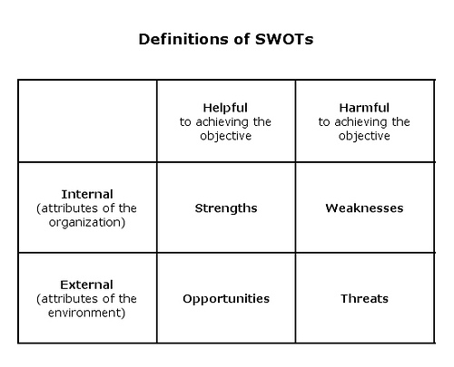
The aim of any SWOT analysis (which is in effect what we are asking each unit to do as part of the Annual Planning process) is to identify the key internal and external factors that are important to achieving the unit’s goals and objectives. SWOT analysis groups key pieces of information into two main categories:
- Internal factors – strengths and weaknesses internal to the unit
- External factors – opportunities and threats presented by the external environment (outside the control of the unit)
Definitions and Examples
SWOTs are sometimes confused with possible strategies. SWOTs are descriptions of conditions, while strategies define the actions to be taken and would be addressed in your planning requests narrative.

- Strengths: attributes of the unit that are helpful to achieving its objectives (goals).
  - Example: There is a high-level of communication among members of the unit
  - Example: A growing retention rate.
  - Example: A survey given to the campus community indicates an improved level of satisfaction
- Weaknesses: attributes of the unit that are harmful to achieving its objectives
  - Example: A decreasing pass rate
  - Example: Length of time to respond to requests has increased
  - Example: Staff inadequately trained/prepared for the tasks they are assigned
  - NOTE – lack of funds/money is not a weakness
- Opportunities: external conditions that are helpful to achieving the unit’s objectives.
  - Example: Growing demand for students with skills developed from the unit’s coursework
  - Example: Grants made available to support the unit’s activities
  - Example: Increasing number of students graduating from feeder high schools
  - Example: Changes in technology that would allow more efficient service
- Threats: external conditions that are harmful to achieving the unit’s objectives
  - Example: Increase in shipping costs for necessary supplies
  - Example: Decrease in open positions for students graduating with degree in the area
  - Example: Outside sources offering the same services at less cost to the campus
  - Example: Technology has made the services offered obsolete
  - NOTE – lack of funds/money is not a threat

Using SWOT

SWOTs can be used as inputs to the generation of strategies or to help gain an understanding of a unit’s current status. Asking and answering each of the following four questions may help clarify your plan:
    - How can we Use each Strength?
    - How can we Stop each Weakness?
    - How can we Exploit each Opportunity?
    - How can we Defend against each Threat?

