Crafton Hills College
Diversity and Inclusion Plan

Spring 2017

Table of Contents

SIGNATURE PAGE…………………………………………………..…………………………… 3
EXECUTIVE SUMMARY.…………………………….………………………….……….……. 4
Program Introduction……………………………..…………………………………. 4
Committee…………………………………………………………………………………. 4
Media………………………………………………………………………………………… 4
Contact Person……………………………..…………………………………………… 5
CAMPUS-BASED RESEARCH……………………………..…………………………………. 5
GOALS AND ACTIVITIES……………………………..……………………………………….. 6
RESOURCES AND BUDGET……………………………..…………………………………… 9
EVALUATION SCHEDULE AND PROCESS.…………………………….……….….... 10
ENDNOTES…………………………….……………………….….………………….…….…… 11

Signature Page

District: San Bernardino Community College District
Date Approved by Board of Trustees:

College President:
Dr. Wei Zhou

Vice President of Student Services:
Dr. Rebeccah Warren-Marlatt

Vice President of Instruction:
Dr. Kathy Bakhit

Academic Senate President:
Professor Denise Allen Hoyt

Diversity and Inclusion Faculty Lead:
Professor Breanna Andrews

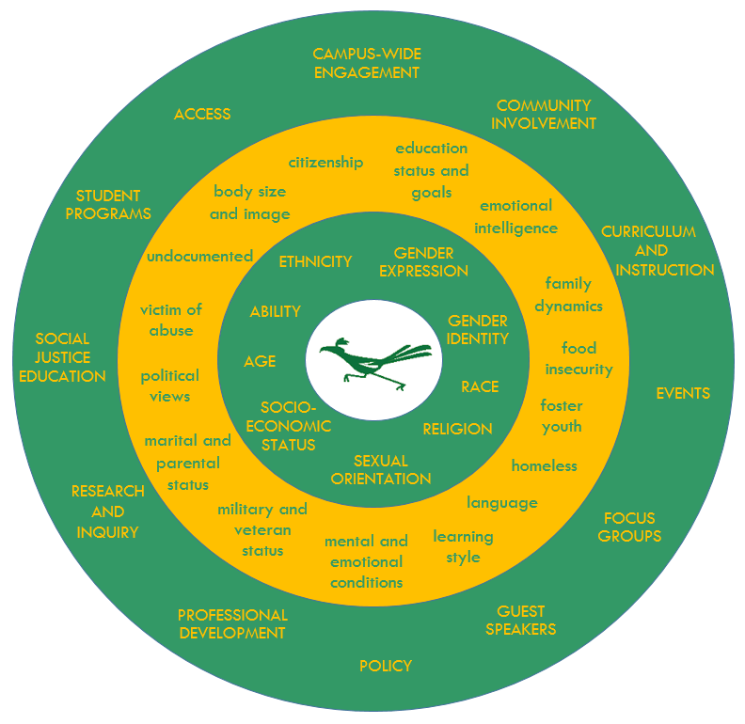
Executive Summary
Program Introduction
Mission: To intentionally educate and raise awareness of diversity in all of its forms through collaboration and advocacy.
Vision: To create an inclusive campus community where individuality is recognized, differences are celebrated, and everyone has the opportunity to engage, learn, and advance.
Values: Individual differences, equal access, and inclusion of all community members.
Figure 1 lists protected classes in the center green circle, followed by other markers of diversity in the center yellow circle. The outer green circle lists methods of education the Diversity and Inclusion program uses to educate and celebrate our diversity.
Figure 1

Committee
The Diversity and Inclusion Committee recognizes we are a learning institution that provides a welcoming environment to our evolving campus population and empowers each member of the community to flourish. This occurs through critical reflection, acceptance, and the quest to find our individual truths.
The Diversity and Inclusion Committee intentionally educates and raises awareness of diversity in all of its forms through actively participating in collaboration, advocacy, and analysis of campus policy. The committee is also responsible for hosting programs and events, as well as promoting and nurturing a campus culture of civility. We seek to create an inclusive campus community where individuality is recognized, differences are celebrated, and everyone has the opportunity to engage, learn and advance.
This committee meets every 2nd and 4th Thursday of each month from 9:00-10:30am in CCR-155, and is composed of two Student representatives, two Staff representatives, two Faculty representatives, and two Management representatives. Other campus members are welcome to attend. The Diversity and Inclusion committee first convened on October 13, 2016.

Media
Website: http://www.craftonhills.edu/current-students/diversity-and-inclusion/index.php
Facebook: https://www.facebook.com/CHCDiversityandInclusion/
Email: CHCdai@sbccd.cc.ca.us
Contact Person
Breanna Andrews, American Sign Language Faculty, is the current contact person for the Diversity and inclusion program. She currently holds the title “Faculty Lead, Diversity and Inclusion.”
Campus-Based Research
Historical research has shown a positive relationship between school cultures that promote diversity and inclusivity and: student engagement (Brady, 2005) (Denson & Chang, 2009); student satisfaction with their college experience (Villalpando, 2002); learning and academic attainment (Denson & Chang, 2009) (Gottfredson, et al., 2008); and students’ activist involvement with campus diversity (Zuniga, Williams, & Berger, 2005).
The Community College Survey of Student Engagement (CCSSE) gathers qualitative and process oriented data, and is being administered this semester, Spring 2017, and results will be available in the fall 2017 semester.
Past CCSSE results (2011) showed that, when CHC student responses were compared to students at other Hispanic-serving institutions, CHC students were less likely to feel that multicultural issues were included in their coursework quite a bit or extremely (37% vs. 44%); and were slightly less likely to feel that they “belong” (64% vs. 68%) (Garvin, 2013).
When looking at the Crafton Hills College 2017 Student Equity Data report, “results indicate access, the transfer rate, and the degree and certificate completion rate, were the three areas where disproportionate impact was most likely to occur. African American, 20 – 24 year olds, and DSPS students were the groups most likely to be disproportionately impacted. African American and 20 – 24 year old students were more likely to have substantially lower math and English throughput rates and lower degree/certificate and transfer rates. In addition, Hispanic students were more likely to have substantially lower degree/certificate completion rates and transfer rates” (Wurtz, 2017).
These results suggest that additional work must be done at CHC to improve the quality and frequency of staff and faculty contact with students, and to promote a more individualized approach to supporting our diverse learners.
The Equity outcomes that this initiative will most likely impact will be access (working adults, veterans, students with disabilities, and undocumented students); course completion (foster youth); basic skills completion (African American, Hispanic, and economically disadvantaged students). It is also reasonable to assume that, because students are more likely to stay in college and complete their academic goals when a college is welcoming and inclusive, there would be a positive impact on degree and certificate completion (males, African Americans, Hispanics, Native Americans, and students aged 20-34 years; and on transfer (African Americans, Hispanics, and students aged 20-24 years). This positive climate change will likely make LGBTQ and diverse religious groups feel more comfortable on campus as well.
Goals and Activities
The purpose of Crafton Hills College’s Diversity and Inclusion program and its processes is to influence the college culture to become more inclusive, diversity-minded, accepting, and aware of the issues diverse populations sometimes face; to recognize the strengths and assets diverse groups bring to the college; and to create ways to recognize and celebrate diversity as an institution. The program’s initiatives, which align closely with the District EEO Plan, has two main focuses, which may overlap at times: Student education and engagement; and Staff/Faculty education and engagement. To advance the purpose of the program, the Coordinator will work with the Diversity and Inclusion Committee to create a programmatic approach to recognizing and celebrating diverse groups; develop booklets and pamphlets promoting diversity; sponsor surveys and focus groups to better understand diverse perspectives; develop a Diversity and Inclusion website; build connections with community organizations and resources for diverse groups; and create a strategic plan for the Diversity and Inclusion Initiative. The Coordinator will also work closely with the Professional Development Coordinator and with the District EEO and Professional Development officers to ensure a comprehensive approach to diversity that includes policies that promote inclusion, as well as increased awareness and appreciation of others, improved communication skills with all people, and the development of interpersonal emotional intelligence competencies among staff, faculty, and managers.
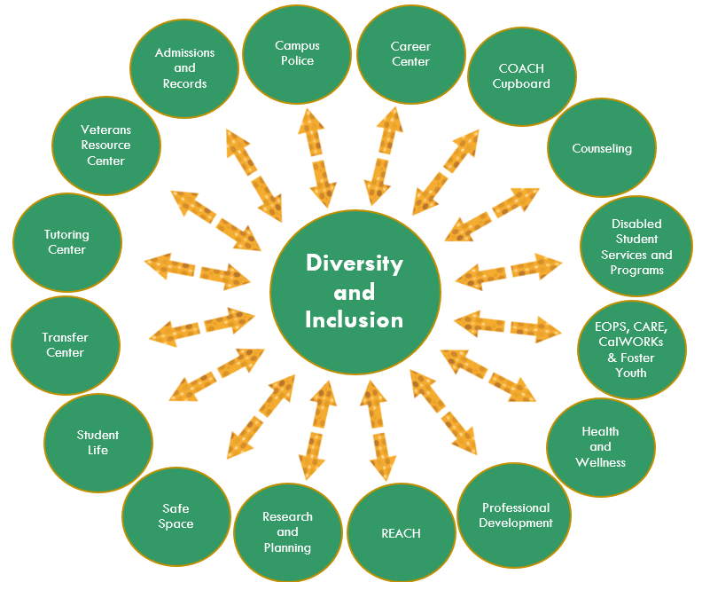
The purpose of the Diversity and Inclusion program and its processes are two-fold. First, programming will be developed to positively impact campus climate, increase student and faculty/staff knowledge, influence attitudes, and improve teaching and service to become more inclusive and accessible. This approach to campus climate change has not previously existed at Crafton Hills College. While outstanding work is being done at the College around diversity and inclusion, such as Safe Spaces, many student club activities, diversity-themed theater productions and art shows, curriculum in many disciplines that includes multicultural content, our data shows that there is still room for improvement. Figure 2 shows the intersection of the Diversity and Inclusion mission with educational domains, such as access, community involvement, and social justice education; with student statuses and contexts, such as military veteran, undocumented, and food-insecure; and with group membership, such as race, gender, age, and disability. The Diversity and Inclusion program will address diversity and inclusion on all these dimensions on multiple measures and varying degrees.
Figure 2

Second, the program will include the review of policies and procedures for their accessibility and alignment with legal mandates and their use of inclusive language and ideas. For example, the incumbent Diversity and Inclusion Coordinator has worked to include preferred names on faculty rosters, and to ensure that all-gender bathrooms are placed on campus maps. The coordinator will serve on college committees and connect with student organizations to ensure the goals of the diversity and inclusion initiative are advanced throughout the campus.
To effect the important cultural change that will allow every student, staff, faculty member, and community member to feel included and appreciated, the college needs a program that has the staffing, leadership, and resources to keep issues of diversity on the forefront of the college’s agenda.
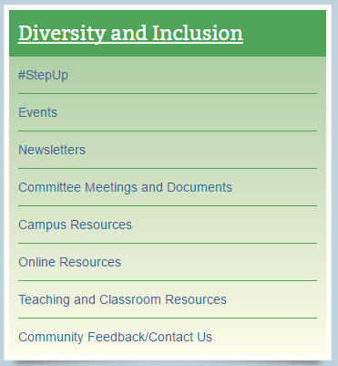
Specific Activities and Initiatives include:
- Monthly Newsletters
- Weekly campus email updates
  - Upcoming on-campus events
  - TedTalks
  - Current events (nation-wide/world-wide)
  - Upcoming Diversity related conferences and other learning opportunities
- Workshops
- Cross-Cultural Communication
- Continuation of Cultural Education Series (Safe Space, UndocuAlly, Vet Net)
- Add new Cultural Education Series (ability, homelessness, etc.)
- Student Communication Series: One for employees (“How to pull info out of students”), and one for students (“how to ask the right questions”)
- Targeted “in-reach” focus groups to collect qualitative data regarding students’ experiences their coming to Crafton; Are our people, information, and signage helpful? Do students feel comfortable stating their personal views in class and within various offices and departments on campus?
- Build and maintain website and resources (see navigation menu above to the right)
- Campus Climate Initiatives
- #StepUp
- Cultural Celebratory Events
- Creation and distribution of posters around campus
- Educational slides added to TVs in Crafton Center
- Establish a campus Cultural Center (currently on Facilities Master Plan)
- Review policies and procedures to reduce or eliminate unintended barriers
  - Review APs and BPs
  - All Gender Bathrooms
  - Preferred Names on Rosters
  - Homeless Student Support
  - Develop process for international students to meet IGETC requirements when country of origin will not release transcripts (LOTE)
- Collaboration with various campus departments
- Admissions and Records: preferred names on rosters
- Career Services: Clothing Closet
- Counseling: Dreamers/UndocuAlly
- DSPS and Professional Development: UDL series
- EOPS: D&I Workshops satisfy EOPS Student workshop requirement
- Foster Youth: Workshop/Student Panel
- Facilities: All-Gender Bathrooms
- Homeless Student Support
- Student Life
- Tutoring Center: Student Safe Space Ally Training
- Veterans Center: Military Appreciation events
- Collaboration with District and San Bernardino Valley College to gain ideas and resources, and maintain consistency in our approach to policy change and programming
- Collaboration with community organizations
- Inland Empire Autism Society
- Option House
- PossAbilities
- San Bernardino Country, Department of Public Health
- University of California, Irvine
- University of Redlands, Counseling
- Youth Hope
- Become a model Diversity and Inclusion program for other small community colleges

Resources and Budget
Item 1: Salary, Coordinator of Diversity and Inclusion
Description: Provide oversight and direction to the future campus Cultural Center and carry out tasks mentioned above.
Cost: $ 108,690 ($80,718 salary; $27,972 benefits) - Ongoing

Item 2: Supplies Budget
Description: National memberships, various publications, printing materials, and event/workshop supplies as needed.
Cost: $1,000 - Ongoing

Item 3: Contracts
Description: Contracts for guest speakers and presenters to deliver up to date information to the campus regarding specialty areas of diversity.
Cost: $20,000 - Ongoing

Item 4: Part-time Clerical Support
Description: part time individual to assist in scheduling of events, advertising, and community connections.
Cost: $20,000 - Ongoing

Item 5: Food and Other
Description: Provide food to participants engaged in events, workshops, etc.
Cost: $4,000 - Ongoing

Evaluation Schedule and Process
The table below describes an approach to gathering evidence. Processes and outcomes were chosen based on the literature cited above. Data will be examined longitudinally, and disaggregated by group membership to detect patterns of response and to inform institutional improvement.
Outcome | Method | Timeline
Student Engagement | CCSSE | Every two years, in spring
Student Satisfaction | Student Satisfaction Survey | Every two years, in spring (alternates with CCSSE)
Students’ Feelings of Belongingness | CCSSE | Every two years, in spring
Learning Outcomes and Cognitive Gains | ILO Assessment  GPA Analysis | Annual
Staff and Faculty Self-Assessment of communication with and acceptance and understanding of those who are different from oneself | Annual | Annual
Student Engagement | OIERP Student Engagement Survey | Annual
In addition to student outcomes, the program will gather data regarding participation in diversity events and student participation in activism and advocacy.

End Notes
Brady, P. (2005). Inclusionary and exclusionary secondary schools: The effect of school culture on student outcomes. Interchange, 36: 295.
Denson, N., & Chang, M. J. (2009). Racial diversity matters: The impact of diversity-related student engagement and institutional context. American Educational Research, (46), 322-353.
Garvin, R. (2013, Spring). Hispanic student success--comparison of Crafton Hills Collge students to students at other Hispanic-serving institutions. Did You Know?, p. 1.
Gottfredson, N. C., Panter, A. T., Daye, C. A., Allen, W. A., Wightman, L. F., & Deo, M. E. (2008). Does diversity at undergraduate institutions influence student outcomes? Journal of Diversity in Higher Education, 80-94.
Guadiana, L. (2014). Spring 2009, 2010, 2011, & 2013 CHC CCSSE Results by Year. Yucaipa: Crafton Hills College.
Villalpando, O. (2002). The impact of diversity and multiculturalism on all students: Findings from a national study. NASPA Journal.
Wurtz, Keith (2017). Crafton Hills College Student Equity Data. Yucaipa: Crafton Hills College.
Zuniga, X., Williams, E. A., & Berger, J. B. (2005). Action-oriented democratic outcomes: The impact of student involvement with campus diversity. Journal of College Student Development, 660-678.

